**Question 1:**

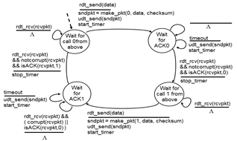

**Question 2:**

**Solution: No. All communication sessions have a client side and a server side. In a P2P file-sharing application, the peer that is receiving a file is typically the client and the peer that is sending the file is typically the server.**

**Question 3:**

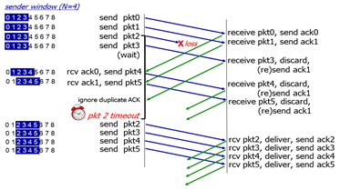

**Question 5:**

### SOLUTION

1. The times where TCP is in slow start are: 1,2,3,13,14,15,24,25,26,28,29,31,35,40  
  
2. The times where TCP is in congestion avoidance are: 4,5,6,7,8,9,10,11,12,16,17,19,20,21,22,23,27,30,32,33,34,36,37,38,39  
  
3. The times where TCP is in fast recovery are: 18  
  
4. The times where TCP has a loss by timeout are: 12,23,27,30,34,39  
  
5. The times where TCP has a loss by triple duplicate ACK are: 17  
  
6. The times where the ssthresh changes are: 18,24,28,31,40  
  
The complete solution is shown in the figure below:

* For intervals of time when TCP is in slow start, the plotted value of cwnd is shown as a green square
* For intervals of time when TCP is in congestion avoidance, the plotted value of cwnd is shown as a yellow square
* For intervals of time when TCP is in fast reccovery, the plotted value of cwnd is shown as an orange square
* The values for ssthresh are shown following a change as a red plus sign
* A flight of packets experiencing a loss has the loss type (which determines the next value of cwnd) labeled above

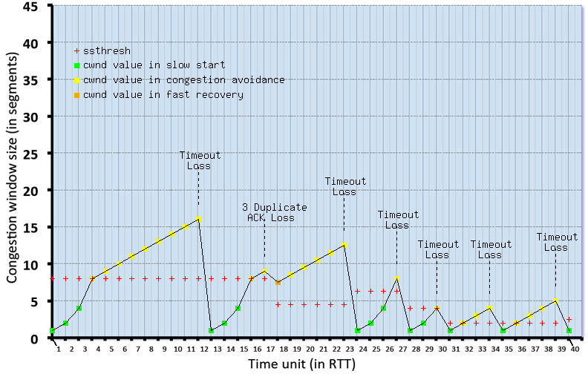

**Question 6:**

1. Step 1: IP address is extracted from the IP packet header.

Step 2: IP prefix matched with forwarding table and corresponding output interface is read.

Step 3: The IP packets is sent to the output interface queue for further processing.

1. The data packets using forwarding tables to traverse down the shortest paths which are calculated by routing algorithms.